**Getting Started**

1. After logging into the Dashboard, click on “Pages” to edit the individual pages of the website.
2. You can start with the Home page if you like. Simply click on “Home” to get started.

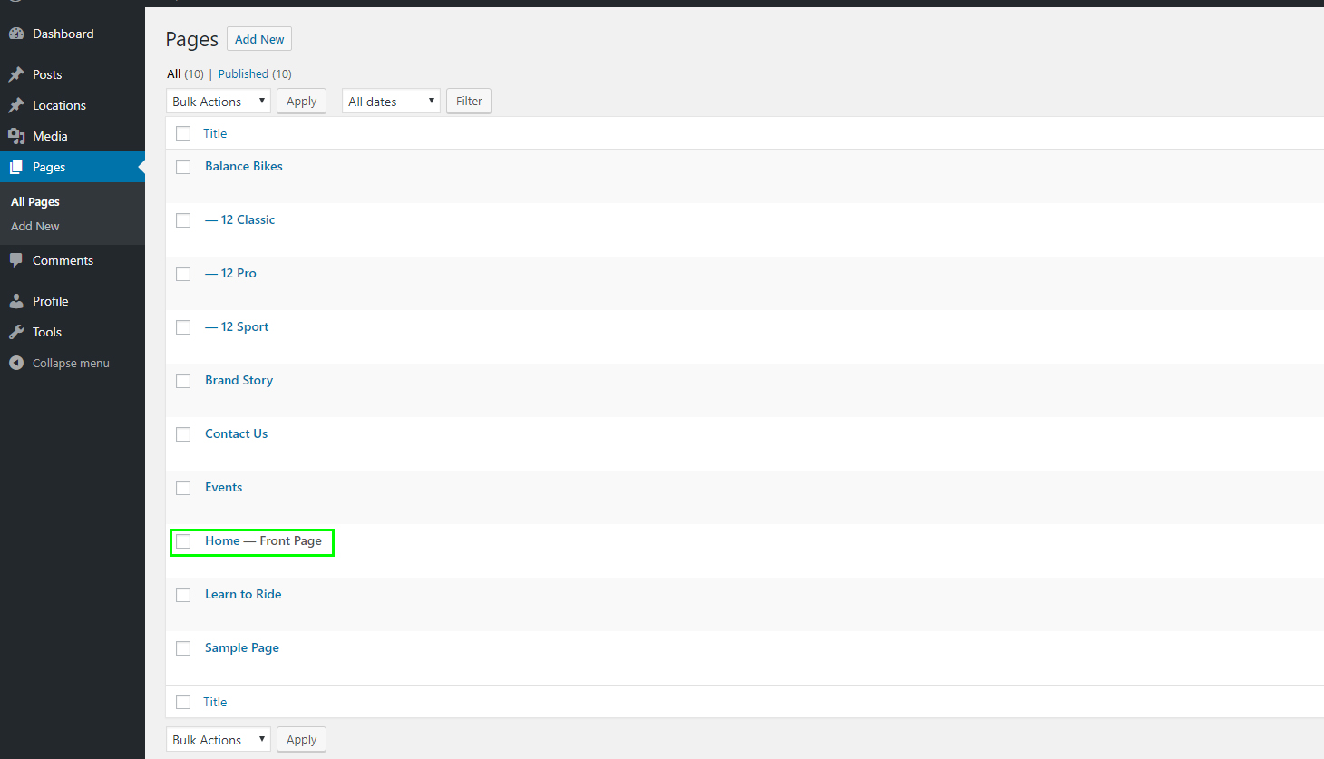

**Translating Pages**

1. Translate the title of the page from “Home” to desired title.
2. Translate the label ’See the Bikes>’ but do not remove the symbols ‘>’
3. Translate the label ‘Learn to Ride>’ but do not remove the symbols ‘>’
4. Translate the other text ares seen here bound in green boxes.
5. Click the uppermost “Update” button to save your progress.
6. Updating the text inside the image rotator will be covered in the next section.

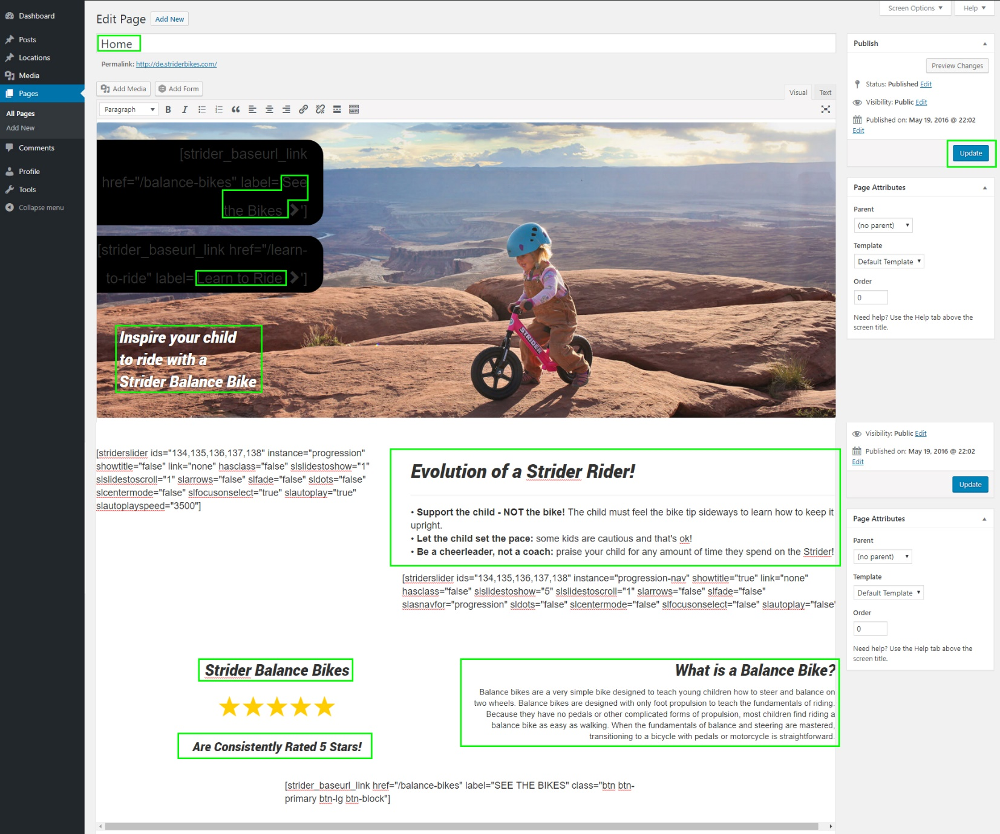

**Rotating Images**

1. Under “Media” click on the images seen here bound in green to edit the Evolution of a Strider Rider section of the Home page.

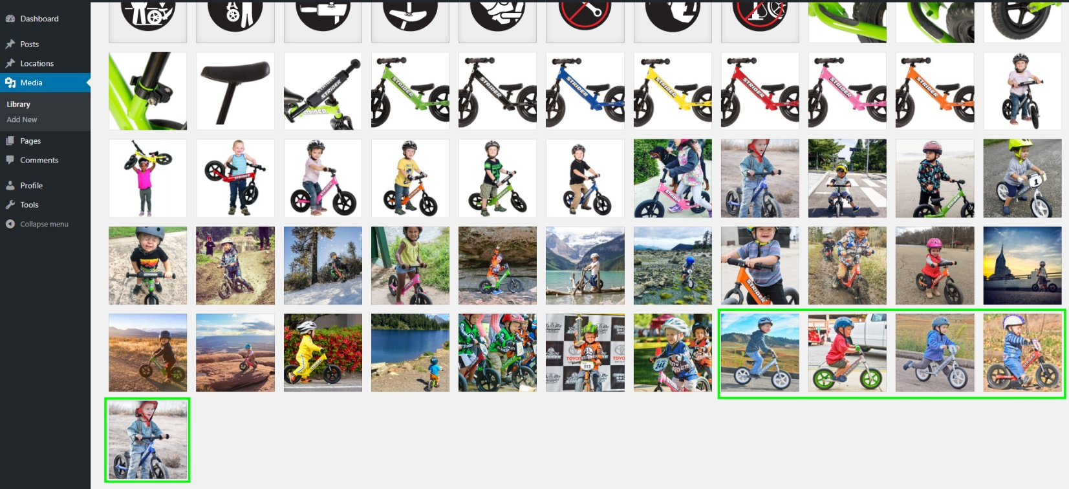

1. Translate the information seen here bound in a green box.
2. Click anywhere in the gray area to save changes.

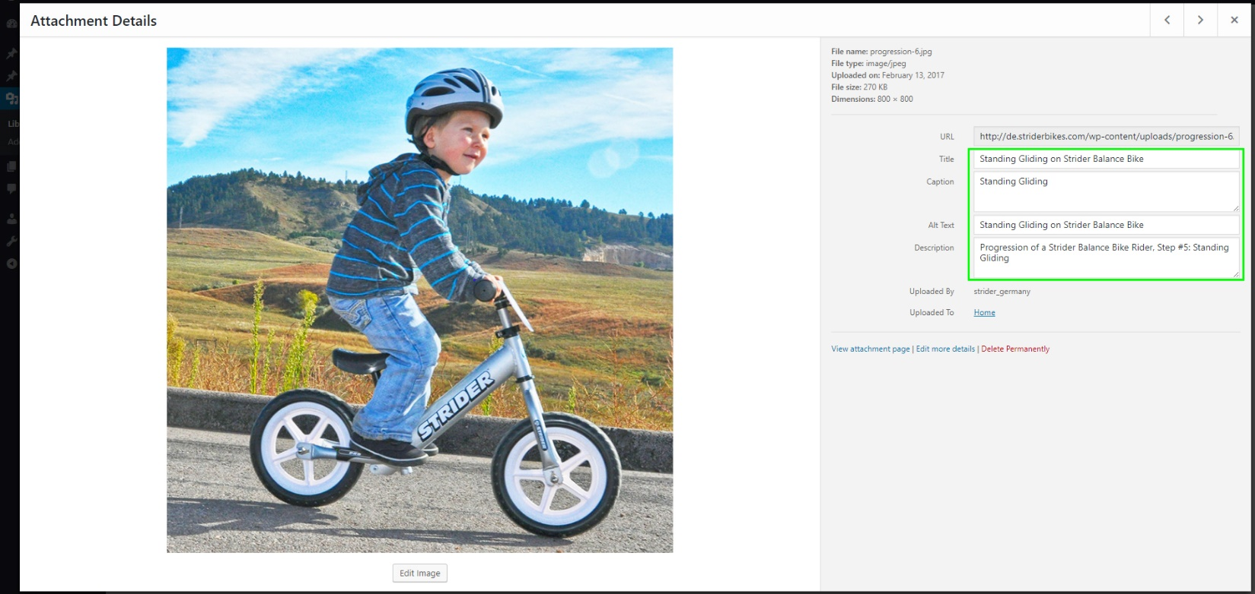

**Balance Bikes page**

1. Under the “Pages” menu, select “Balance Bikes”
2. Translate the title of the page from “Balance Bikes” to desired title.
3. Translate the label ’Shop Now’ but do not remove the symbols ‘ ’
4. Translate the other text areas seen here bound in green boxes.
5. Click the “Update” button to save your progress.

Translating the “Strider Comparison Chart” will be covered in a later section.

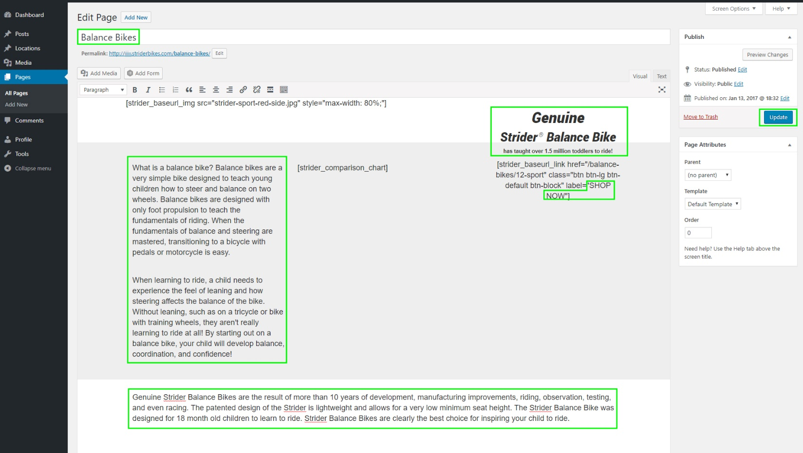

**Learn to Ride page**

1. Under the “Pages” menu, select “Learn to Ride”
2. Translate the title of the page from “Learn to Ride” to desired title.
3. Translate the label ’See the Bikes’ but do not remove the symbols ‘ ’
4. Translate the other text area seen here bound in a green box.
5. Click the “Update” button to save your progress.

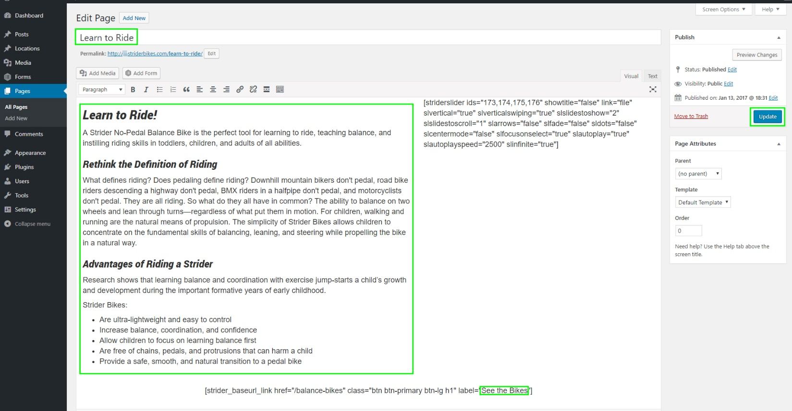

**Brand Story page**

1. Under the “Pages” menu, select “Brand Story”
2. Translate the title of the page from “Brand Story” to desired title.
3. Translate the other text area seen here bound in a green box.
4. Click the “Update” button to save your progress.

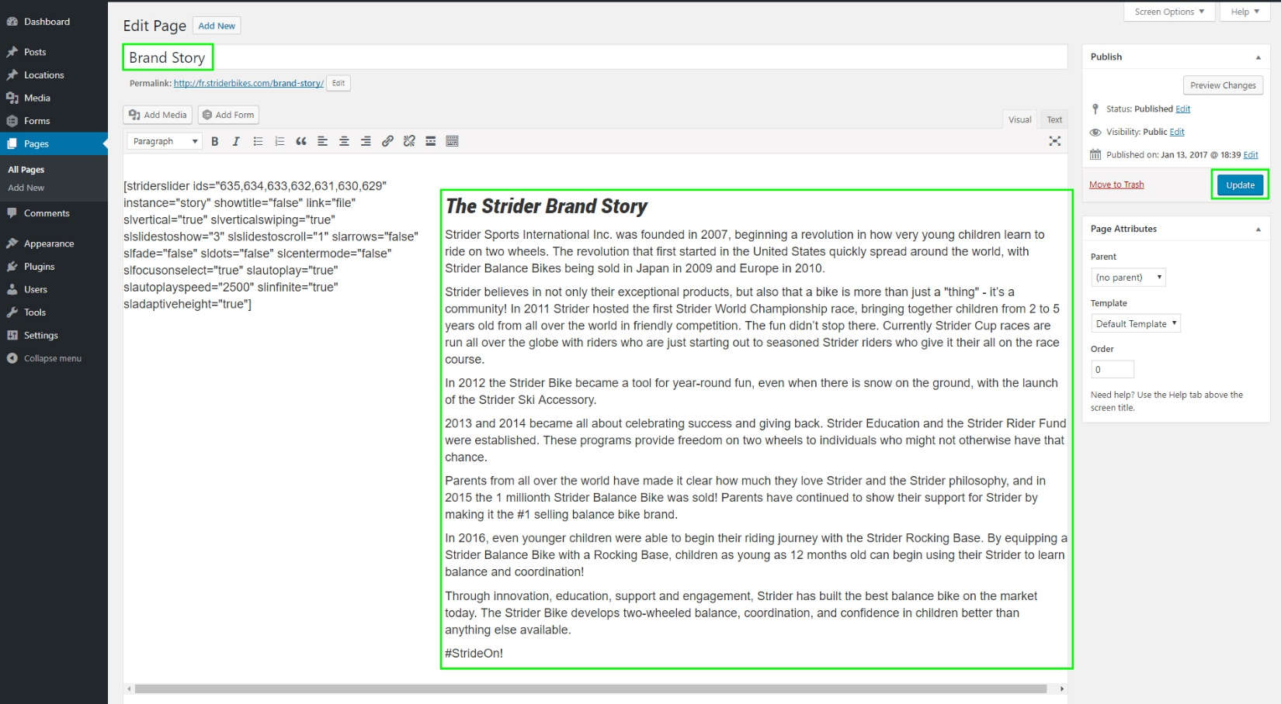

**Contact Us page**

1. Under the “Pages” menu, select “Contact Us”
2. Translate the title of the page from “Contact Us” to desired title.
3. Translate the other text area seen here bound in a green box.
4. Click the “Update” button to save your progress.

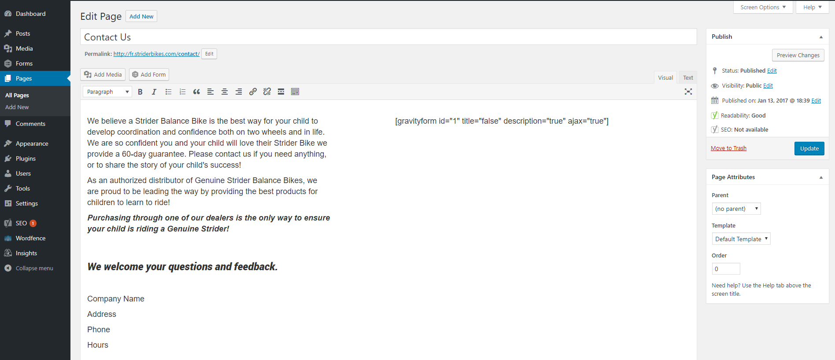

INSERT YOUR COMPANY INFORMATION

**Events page**

1. Under the “Pages” menu, select “Events”
2. Translate the title of the page from “Events” to desired title.
3. Translate the other text areas seen here bound in green boxes.
4. Click the “Update” button to save your progress.

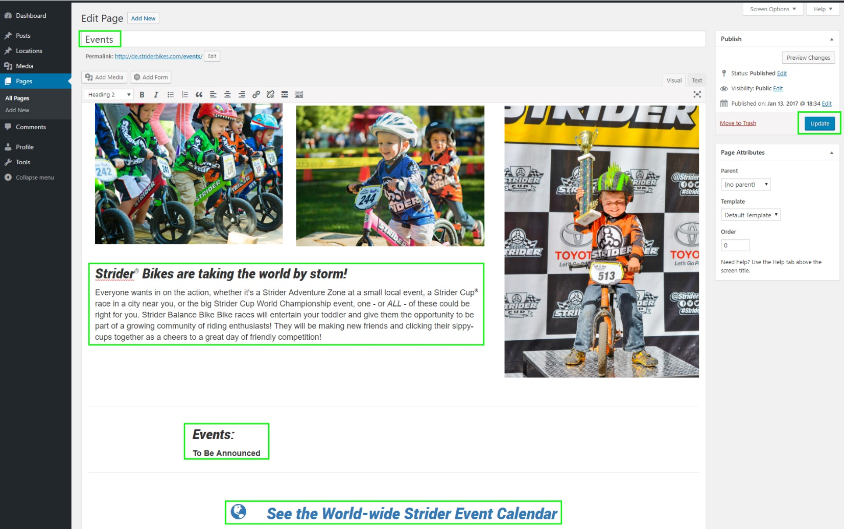

ADD YOUR EVENTS HERE

Be sure to keep link to http://www.striderbikes.com/events

**Next: Translate bike details pages; — 12 Classic, — 12 Sport,** **— 12 Pro**

Translate all areas seen on the following pages bound in green. Click “Update” to save progress.

